# Ascension to Excellence (A2E) Program Information

A2E Promotion Process

A2E Eligibility – Frontline Call Takers

 A2E Eligibility – Offline eCare

Career Mapping

Care Goals

Navigating A2E in LearningHub

LearningHub Information

FAQs

Related Document

**Description:** A2E can assist you in continuing your growth with CVS Health and provide you with the information you need to navigate your career path and demonstrate the Heart at Work behaviors. This job aid provides an overview of the program and offers guidance on navigating the A2E Program in LearningHub.

|  |
| --- |
| A2E Promotion Process |

**Manager Call Review:** Manager will review two calls from prior thirty days. If CCR demonstrates How We Work Behaviors the CCR continues the ascension process.

** Director Call Review:** Director will review two calls from prior thirty days. These two calls will be different than the audits completed by the manager. If the calls display How We Work Behaviors, the submission is approved, and ascension is complete.

**If Approved:** Upon Successful Promotion to CCR II or CCR III, CCR receives the appropriate title change and a 6% pay increase.

**If Denied:** During the call review process, if it is determined that additional development is needed, the colleague’s leader will develop an action plan to address the areas of opportunity.

* **30 Day Follow Up:** The colleague may then be reevaluated for A2E 30 days later if they still meet A2E eligibility. During re-evaluation, if the call reviews still have areas of opportunity, a second action plan will be implemented to assist with further development.
* **60 Day Follow Up:** 60 days later, the CCR may be revaluated for promotion again if still eligible through performance.

Top of the Document

|  |
| --- |
| A2E Eligibility – Frontline Call Takers |

**Heart at Work Behaviors:** Refer to Care Goals.

**Colleague Performance:**

Refer to the table below:

|  |  |  |
| --- | --- | --- |
| **CCR** | **Criteria** | **Goal Requirements** |
| **CCRI – CCRII** | * 6 months tenure (not to include training) * Have a performance rating of Successful Performance (SP) or higher for the last 6 months. * Have a supervisor recommendation. * Have met the goal requirements. * Have completed the Learning Hub Courses for CCRI to CCRII | Must meet the criteria below for 4 of 6 prior months.   * Must have a Yes/Pending for at least 4 Heart at Work Behaviors * Must have an SP or better in 3 of the 4 goals (Quality must be 1 of the 3 goals met)   + If the agent doesn’t receive surveys via Medallia or doesn’t achieve a minimum of 2 surveys in a month this will automatically equate to an SP for that month in the Overall Satisfaction with the representative goal. |
| **CCRII – CCRIII** | * 6 months must have passed since the promotion date of CCRI to CCRII * Have a performance rating of Successful Performance (SP) or higher for the last 6 months. * Have a supervisor recommendation. * Actively participate in the program/support activity * Have met the goal requirements. * Have completed the Learning Hub Courses for CCRII to CCRIII | Must meet the criteria below for 5 of 6 prior months.   * Must have a Yes/Pending for at least 5 Heart at Work Behaviors * Must have an HP or better in Quality. * Must have an SP or better in other 3 goals. * If the agent doesn’t receive surveys via Medallia or doesn’t achieve a minimum of 2 surveys in a month this will automatically equate to an SP for that month in the Overall Satisfaction with the representative goal. |

Top of the Document

|  |
| --- |
| A2E Eligibility – Offline eCare |

**Heart at Work Behaviors:** Refer to [eCare Customer Care Goals (074313)](https://thesource.cvshealth.com/nuxeo/thesource/#!/view?docid=95d04ce3-448f-402f-b9de-4cf859e5d0cf).

**Colleague Performance:**

Refer to the table below:

|  |  |  |
| --- | --- | --- |
| **CCR** | **Criteria** | **Goal Requirements** |
| **eCare Rep I to eCare Rep II** | * 6 months tenure (not to include training) * Have a performance rating of Successful Performance (SP) or higher for the last 6 months * Have a supervisor recommendation * Have met the goal requirements * Have completed the Learning Hub Courses for eCare Rep I to eCare Rep II | Must meet the criteria below for 5 of 6 prior months:   * Must have a Yes/Pending for at least 5 Heart at Work Behaviors * Must have an HP or better in Quality * Must have an SP or better in other 3 goals |

Top of the Document

|  |
| --- |
| Career Mapping |

Own your own career! Use the [Care Career Mapping InfoGuide (049877)](https://thesource.cvshealth.com/nuxeo/thesource/#!/view?docid=bb53e90d-b0b3-4767-b470-96a6ea3668f6) to explore, visualize, and discuss a variety of career paths in Care.

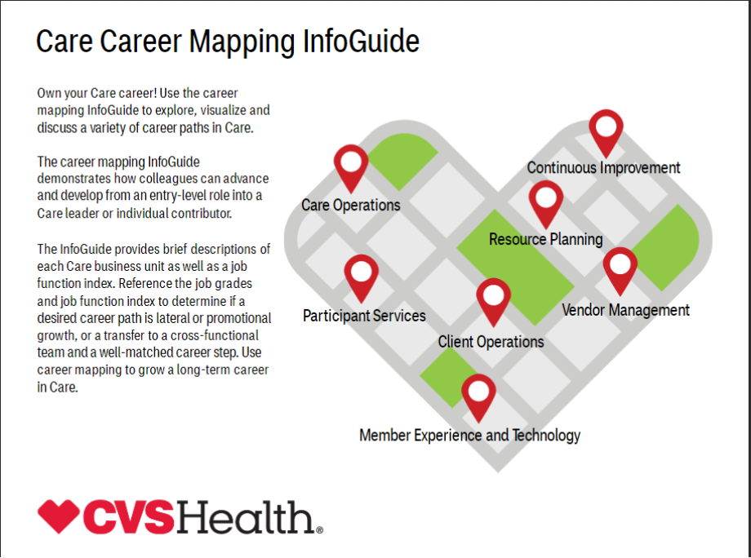

Top of the Document

|  |
| --- |
| Care Goals |

Refer to [Customer Care Representative Goals (115916)](https://thesource.cvshealth.com/nuxeo/thesource/#!/view?docid=9391163d-805a-4b1c-b7e3-532bd914aab3) and [eCare Customer Care Goals (074313)](https://thesource.cvshealth.com/nuxeo/thesource/#!/view?docid=95d04ce3-448f-402f-b9de-4cf859e5d0cf).

Top of the Document

|  |
| --- |
| Navigating A2E in LearningHub |

Complete the steps below:

|  |  |
| --- | --- |
| **Step** | **Action** |
| **1** | * Log in to LearningHub, and under “Groups and Resources,” click **More** and then select the **Ascension to Excellence (A2E)** hyperlink.      * Click the blue **Click Here to learn more about the A2E program** link. |
| **2** | Click one of the following:   * **CCR I to CCR II** * **CCR II to CCR III**    + **For eCare, select CCR II to CCR III**     **Note:** Take some time and check it out. You won’t be disappointed. |

Top of the Document

|  |
| --- |
| LearningHub Information |

The A2E program information is now in LearningHub. The following are the required A2E LearningHub courses:

* **CCR I to CCR II:** 
  + 0000288081 – Customer Service: Strengthening Your Service Skills
  + 0000602728 - Overcoming Barriers to Effective Listening (Video)
  + 082902000 - Listening Attentively (Book)
  + 459631690 – Active Listening and Customer Feedback (Video)
* **CCR II to CCR III & eCare Rep I to eCare Rep II:** 
  + 689825153 – Dealing with Customer Service Incidents and Complaints
  + 169209535 – Effective Communication

Top of the Document

|  |
| --- |
| FAQs |

Use the Q&A table below:

|  |  |  |  |  |
| --- | --- | --- | --- | --- |
| **#** | **Question** | **Answer** | | |
| **1** | **What is Ascension to Excellence?** | The Ascension to Excellence (A2E) program is a promotion program set in place to help customer care representatives promote into higher levels (CCR I to CCR III and eCare Rep I to eCare Rep II) and serves as a preparation and transition tool for colleagues moving from a front-line representative to Senior Team role and Senior Team to Leadership role. | | |
| **2** | **How does a colleague qualify for A2E?** | To qualify for front level promotions, a colleague should meet the following criteria: | | |
| **CCR** | **Criteria** | **Goal Requirements** |
| **CCRI – CCRII** | * 6 months tenure (not to include training) * Have a performance rating of Successful Performance (SP) or higher for the last 6 months * Have a supervisor recommendation * Have met the goal requirements * Have completed the Learning Hub Courses for CCRI to CCRII | Must meet the criteria below for 4 of 6 prior months.   * Must have a Yes/Pending for at least 4 Heart at Work Behaviors * Must have an SP or better in 3 of the 4 goals (Quality must be 1 of the 3 goals met)   + If the agent doesn’t receive surveys via Medallia or doesn’t achieve a minimum of 2 surveys in a month this will automatically equate to an SP for that month in the Overall Satisfaction with the representative goal. |
| **CCRII – CCRIII** | * 6 months must have passed since the promotion date of CCRI to CCRII * Have a performance rating of Successful Performance (SP) or higher for the last 6 months * Have a supervisor recommendation * Actively participate in the program/support activity * Have met the goal requirements * Have completed the Learning Hub Courses for CCRII to CCRIII | Must meet the criteria below for 5 of 6 prior months.   * Must have a Yes/Pending for at least 5 Heart at Work Behaviors * Must have an HP or better in Quality * Must have an SP or better in other 3 goals   + If the agent doesn’t receive surveys via Medallia or doesn’t achieve a minimum of 2 surveys in a month this will automatically equate to an SP for that month in the Overall Satisfaction with the representative goal. |
| **eCare Rep I – eCare Rep II** | * 6 months tenure (not to include training) * Have a performance rating of Successful Performance (SP) or higher for the last 6 months * Have a supervisor recommendation * Have met the goal requirements * Have completed the Learning Hub Courses for eCare Rep I to eCare Rep II | Must meet the criteria below for 5 of 6 prior months.   * Must have a Yes/Pending for at least 5 Heart at Work Behaviors * Must have an HP or better in Quality * Must have an SP or better in other 3 goals |
| **3** | **I want to promote to eCare Rep II, CCR II, and/or CCR III. What do I do?** | That’s great news! Your progress and eligibility should be a part of your regular one on one session with your supervisor. Once you have met the criteria to promote, your supervisor will complete the interest form and submit to management for review.  Be sure to review our A2E landing page in Learning Hub under My Projects>Ascension to Excellence (A2E). | | |
| **4** | **If I have met different metrics on average for 4 of 6 months or 5 out of 6 months, will that qualify me for the ascension of CCRI to CCRII, CCRII to CCRIII, or eCare Rep I to eCare Rep II?** | You do not have to meet the same metrics from month to month to qualify. We will take a “mix and match” approach, meaning as long as you are meeting the correct number of metrics consistently from month to month during the full duration you will qualify.  Be sure to review the A2E landing page in Learning Hub under My Projects>Ascension to Excellence (A2E) and partner with your supervisor to make sure you’re on track. | | |
| **5** | **What if I’m on a special project? Does that disqualify me for the A2E Program while I’m helping the business elsewhere?** | The ability to work on a special project will not impact your ability to promote within the normal timeframe. Your supervisor will work with your project lead to ensure that you are meeting any deliverables for the timeframe you have been on the project. | | |
| **6** | **Why should I promote through A2E? Doesn’t everything stay the same?** | There are several. reasons why we want our colleagues to promote through A2E:   * First, we want all our colleagues to have the chance to build their skills and share their expertise with peers. We rely on CCRII and CCRIII agents to help with stretch projects such as LA (Learning Advocates) for our new hires and SME (Subject Matter Experts) for times when we need floor walkers or additional coverage to answer questions. * Secondly, promoting through A2E also helps you earn extra money! There isn’t a person around who has ever said “No, please don’t give me more money…” We want colleagues to be well compensated for the exceptional job you do each day! | | |
| **7** | **Is there anything that could prevent me from promoting through the A2E program?** | In addition to making sure that you are meeting the above listed metrics, you should be in good standing.  If you are on a level of counseling outside of level 1 for attendance, you will be disqualified for a total of three months for level I or II counseling (outside of attendance) and a total of six months for level III counseling.  **Examples:**   * If on a Level I Counseling for attendance, there is no probationary period. * If on a Level I Counseling for non-attendance related behaviors, there is a 3 month wait period. * If on a Level II Counseling for any reason, there is a 3 month wait period. * If on a level III Counseling for any reason, there is a 6 month wait period.   Additionally, any level of counseling delivered in training/onboarding for behaviors outside of attendance will follow you to the floor and would apply to the scenarios above.    The probationary period only impacts the submission date.  **Example:**  John Doe was ready to submit for A2E in January but was placed on a Level 2 Counseling on 1/1/25. They would not be able to submit for A2E until 4/1/25; however, they will still use the metrics from 1/1/25-4/1/25 for submission. Corrective counseling changes the eligible submission date, and all metrics have a 6-month lookback period from the new date of eligibility. | | |
| **8** | **If I did not ascend through the A2E program on the first attempt, what is the process to be reevaluated?** | You must wait a minimum of 30 days to give yourself a full month to implement the feedback your leader has provided. Once 30 days has past, your leader will review your metrics to ensure you are continuing to meet the performance qualifications for ascension. As long as you are achieving current expectations, your leader will start the process after 30 days for reevaluation. | | |

Top of the Document

|  |
| --- |
| Related Document |

[Customer Care Abbreviations, Definitions Terms Index (017428)](https://thesource.cvshealth.com/nuxeo/thesource/#!/view?docid=c1f1028b-e42c-4b4f-a4cf-cc0b42c91606)

Top of the Document

Not to be Reproduced or Disclosed to Others without Prior Written Approval

**ELECTRONIC DATA = OFFICIAL VERSION / PAPER COPY = INFORMATIONAL ONLY**